**COMPONENTS AS BUILDING BLOCKS**

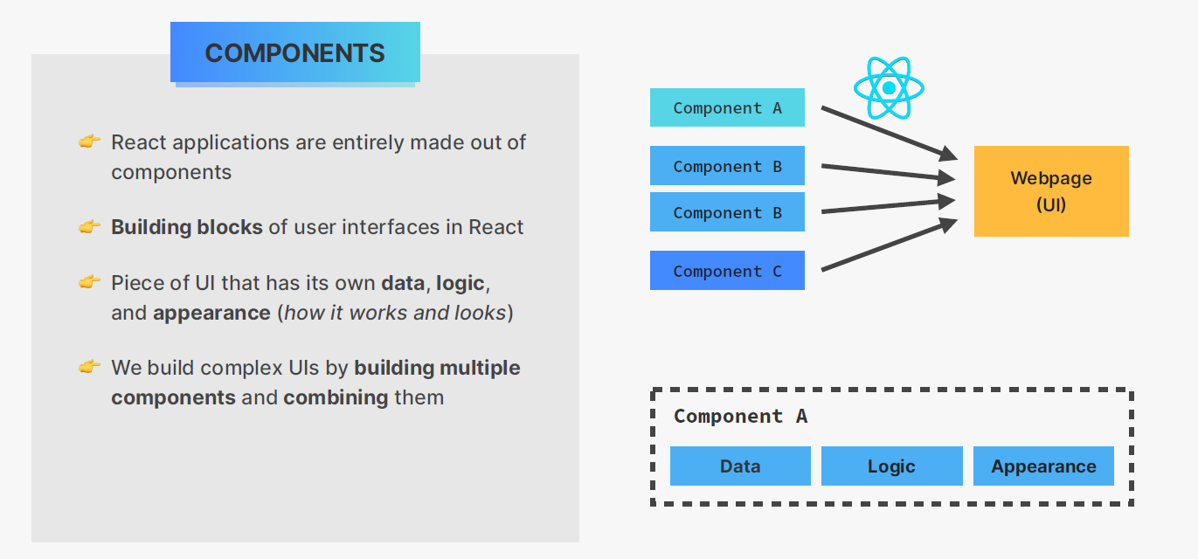

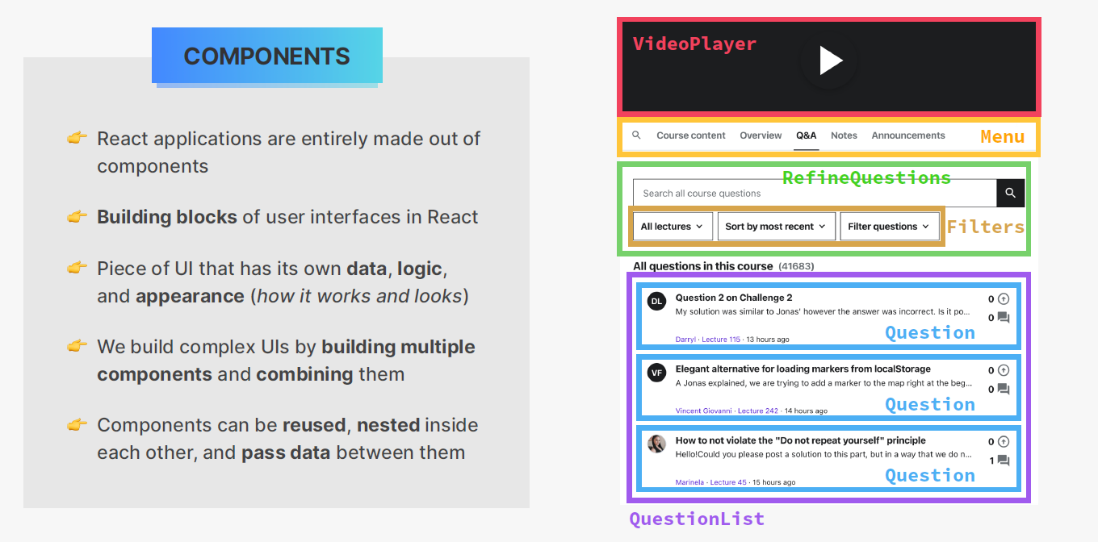

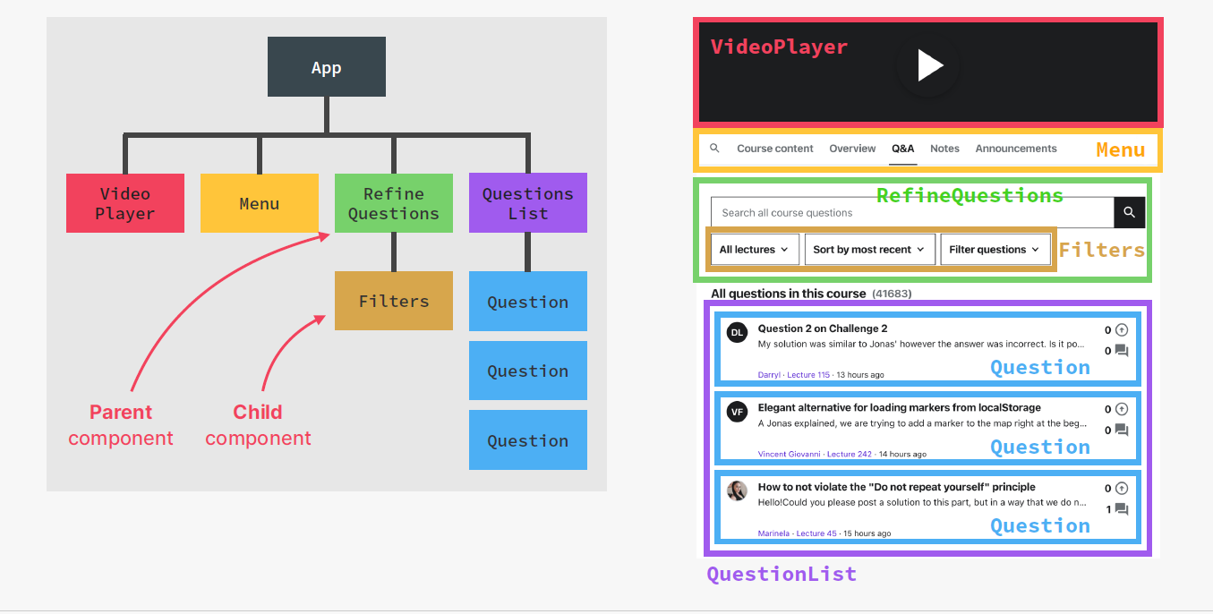

**Do you find it helpful?**

Let me know down in the comments.



[](https://www.linkedin.com/in/anubhav-gupta-b68946132/)

Click To Follow For More On LinkedIN